Item 1 Task a
Through this task we had to block the SQLServerAgent login in the database level. It was done by denying CONNECT permission to that account inside the restaurant database.

Execution Results
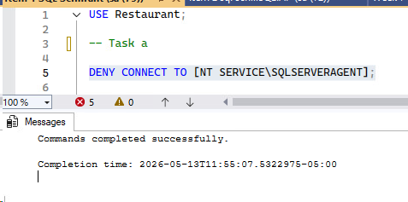
Figure 1 Execution Results for item 1 task a

Item 1 Task b
Through this script it creates a database user that is named as RestaurantUser without linking it to a server login it then assigns the user to the db_backupoperator role which allows them to back up the database.

Execution Results
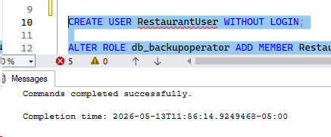
Figure 2 Execution Results for item 1 task b

Item 1 Task c
Through this script it creates a user named RestaurantDoAnything and then adds the user as a member of the db_owner role which lets the user to have the complete control and all the permissions within the Restaurant database.

Execution Results
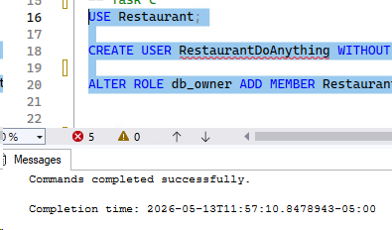
Figure 3 Execution Results for item 1 task c

Item 1 Task d
First, we shifted to the master database because in order to create or drop any database it requires a server level access but not just database level access. Then we created a server level login named as RestaurantAddDeleteDb with a password ‘StrongPassword123!’ and then gave the dbcreator server role. Then after shifting back to the Restaurant database the actual database user for the login has been created and we have denied insert permissions to that user so the user is been blocked from adding data to the tables.

Execution Results
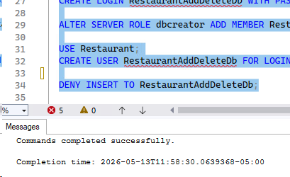
Figure 4 Execution Results for item 1 task d

Item 1 Task e
In this task we have created a new user named RestaurantPower. In order to let them modify other user’s privileges the user RestaurantPower user have been added to both db_securityadmin and db_accessadmin roles.

Execution Results
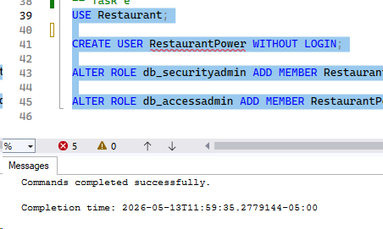
Figure 5 Execution Results for item 1 task e

